Pre-Algebra Name:_________________________________

Trimester 3 Final Exam Review Hour:___________________
TRIMESTER THREE FINAL EXAM REVIEW

We will be taking our last “final” exam on Thursday, June 15th. This exam will assess the content we covered in the third trimester.

You have already seen the final exam. It was the Trimester 3
Pre-Assessment. Taking this exam again, provides you the opportunity to look at your growth and see your areas of strength and those that still may need some improving.

This review packet is a great resource as well as your unit tests and unit notes. The problems highlighted in this packet as well as those on your unit tests are very similar to those on the final exam. We will go over problems from this packet each day prior to the exam.

This exam will be included in your grade. It will count for a FULL test score. It is imperative that you learn how to prepare for a final and what to expect when it comes to taking these types of summative assessments. Please take the time to complete the problems in the packet. Review your Standard scores in PowerSchool to focus your study needs as well.

Unit 9: Graphing
CONTENT COVERED in the THIRD TRIMESTER:
- The Coordinate Plane
  - Finding coordinates
  - Giving coordinates of a point
  - Label Quadrants, x-axis, y-axis and origin
- Graphing
  - Using a Table
  - Writing Equations in Function Form
  - Using the x- and y- intercepts
  - Using Slope-Intercept Form
- Slope
  - Identify the Slope on a Graph
  - Slope Formula
  - Calculate the Slope Given Two Points
Unit 10: Basic Geometry
- Basic Geometry
  - Define Point, Line, Plan, Ray and Line Segment
  - $∼and ≅$
- Similar and Congruent Figures
  - Corresponding Sides
  - Corresponding Angles
  - Ratio of Corresponding Sides
  - Measurement of Missing Sides (Indirect Measurement)
- Scales
  - Find the distance on a map
  - Find the actual distance
  - Scale without Units
- Triangles
  - Classify by Side Length
  - Classify by Angle Measure
  - 180º
- Polygons and Quadrilaterals
  - Identify Polygons (Convex and Concave)
  - Identify Quadrilaterals
  - 360º

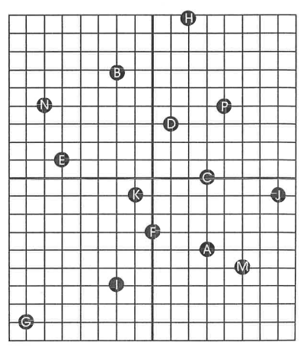
Find the coordinates of the indicated point.
Unit Nine: Graphing

- $A$

- $I$

- $H$

- $C$

- $E$

- $N$

Name the graph (letter) of each ordered pair.

- $(-2,6)$

- $(0, -3)$

- $(5, -5)$

- $(-1, -1)$

- $(-7, -8)$

- $(7, -1)$

Name the quadrant or axis on which each point lies.

- $(-4, 3)$

- $\left(0,6\right)$

- $(4, -2)$

- $(-1, -1)$

- $(-2, 0)$

- $(1, 2)$

Graph the equation by making a table and plotting the points.
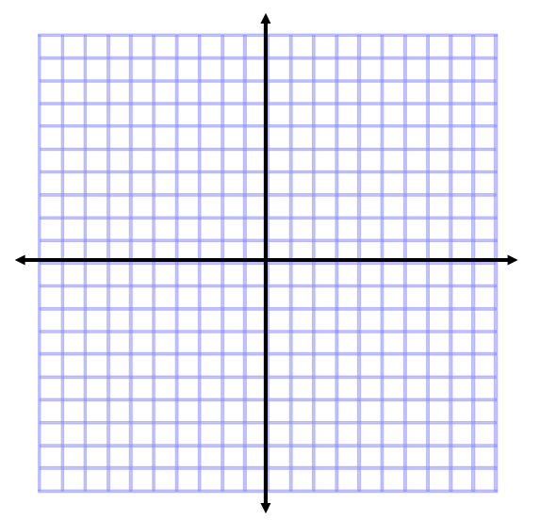
- $y= -3x+5$
x | y

- .$y=5-x$
x | y

- $x= -7$
x | y

- $y=x+3$

x | y

Write the equation in function form.

- $3x+y=9$

- $3x+4y=12$

- $5y=20x-5$

- $12x+6y= -18$

Find the x- and y- intercepts.

- $2x-2y= -4$

- $2x -5y=0$

- $8x+10y=50$

Find the slope.

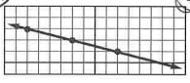

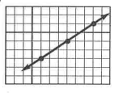

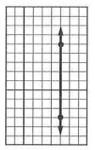

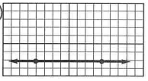

- $\left(5, -2\right)(-7, 4)$

- $\left(6, -9\right)(-4,3)$

- $\left(-4, 8\right)(-4, -3)$

Use slope-intercept form to graph the line.
- $y=2x-4$

- $x-4y+8=0$

Unit Ten: Basic Geometry

Given $EFGH\sim JKLM$, tell whether the statement is true or false.

- $∠F and ∠J$ are corresponding angles.

- $∠H and ∠M$ are corresponding angles.

- $\overline{FG} and \overline{KL}$are corresponding sides.

- $\overline{GH} and \overline{LM}$ are corresponding sides.

- $\overline{HE} and \overline{MJ}$are corresponding sides.

- $∠G and ∠K$ are corresponding angles.

Find the ratio of corresponding sides of figure A to figure B.
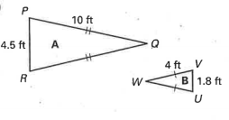

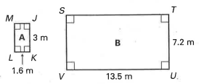

Find the specified side length.

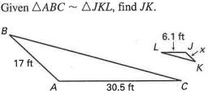

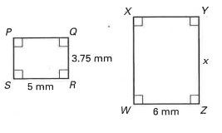
- Given PQRS ~ WXYZ, find YZ

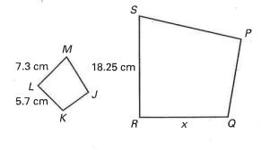
- Given JKLM ~ PQRS, find QR

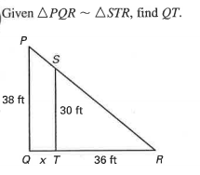

A map has a scale of 1 inch: 12 miles. Use the given map distance to find the actual distance.
- 8 inches
- 42 inches
- $\frac{3}{8}$ inches
- $2\frac{1}{2}$ inches
A map has a scale of 1 cm : 6km. Use the given actual distance to find the distance on the map.
- 24 kilometers
- 33 kilometers
- 7.2 kilometers
- 1.5 kilometers
Write the scale without units.
- 1 in: 14 ft
- 1 cm : 65 m
- 1 in : 30 yd
Find the value of x. Then classify the triangle by its angle measure.
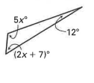

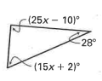

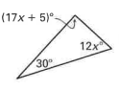

Find the value of x. Then classify the triangle by side length.
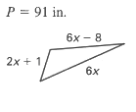

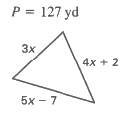

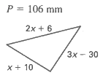

Tell whether the figure is a polygon. If it is a polygon, classify it and tell whether it is convex or concave.

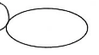

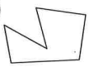

Classify the quadrilateral.

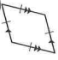

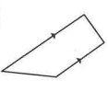

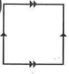

Find the value of x.

