Unit 7: Ratios and Proportions Name:______________________

Pre-Algebra: Practice Test Hour:____________

7.1: I can calculate the unit rate.
1. $\frac{18 chairs}{3 people}$ | 2. $\frac{70 miles}{5 hours}$
3.$\frac{\$161}{7 shares}$ | 4. $\frac{320 tourists}{5 boats}$
7.1: I can simplify complex fractions.
5. $\frac{\frac{1}{2}}{\frac{5}{8}}$ |  | 6. $\frac{1\frac{3}{5}}{\frac{1}{15}}$
7. $\frac{\frac{5}{9}}{\frac{25}{27}}$ |  | 8. $\frac{2\frac{1}{4}}{1\frac{3}{8}}$
 | Score:__________________%

7.2 I can find equivalent rates by conversion.
1. $\frac{300 miles}{20 seconds}=\frac{?miles}{1 minute}$

2. $\frac{45 minutes}{1 mile}= \frac{?hours}{1 miles}$

3. $\frac{440 cups}{1 mile}= \frac{?ounces}{1 yard}$

4. $\frac{8 calls}{1 hour}= \frac{?calls}{1 day}$

Score:_________________%

7.3 I can state whether the ratios for a proportion.
1. $\frac{9}{6}, \frac{156}{104}$ | 2. $\frac{36}{48}, \frac{30}{30}$
3. $\frac{4}{20}, \frac{16}{40}$ | 4. $\frac{16}{48}, \frac{18}{52}$
7.3 I can solve proportions using cross products.
5. $\frac{x}{14}=\frac{10}{4}$ | 6. $\frac{-4x+6}{4}=\frac{5}{2}$
7. $\frac{12}{x}=\frac{0.4}{9}$ | 8. $\frac{28}{x}= \frac{8}{16}$
 | Score:________________%

7.4 I can use a table to find the constant of proportionality.
1. Each pound of green beans costs:

Pounds of Beans (x) | 3 | 5 | 7 | 9 | 11
Cost (y) | $0.99 | $1.65 | $2.31 | $2.97 | $3.63

Equation:
2. Each unicorn costs:

Unicorns (x) | 2 | 4 | 6 | 8 | 10
Cost (y) | $450 | $900 | $1,350 | $1,800 | $2,250

Equation:
3. Each candle costs:

Candles (x) | 1 | 4 | 8 | 12 | 16
Cost (y) | $2 | $8 | $16 | $24 | $32

Equation:
4. For every M&M in the bag, there are_______ green M&Ms:

# of Green M&Ms (x) | 12 | 18 | 24 | 30 | 36
Total # of M&Ms (y) | 48 | 72 | 96 | 120 | 144

Equation:
7.4 I can use a table to determine if a relationship varies directly.
State whether the table represents a proportional relationship.
5.  $$x(years)$$ $$y(coins)$$  0 0  1 3  2 6  3 9  4 12 | $$x(time)$$ $$y(miles)$$  0 0  4 400  20 1,600  40 12,000  80 32,000  6.
 | Score:______________%

7.5 I can find the constant of proportionality and use it to write an equation.
1. $y=25;x=5$ | 2. $y=36;x=4$
3. $y=30;x=3$ | 4. $y=4;x=\frac{1}{4}$
7.5 I can tell whether x and y are related directly.
5. $y=\frac{1}{2}x$ | 6. $\frac{1}{3}y=x$
7. $x=\frac{y}{2}$ | 8. $y=x+1$
 | Score:__________________%

7.6 I can graph solutions to direct variation equations. Write the equation for each line.
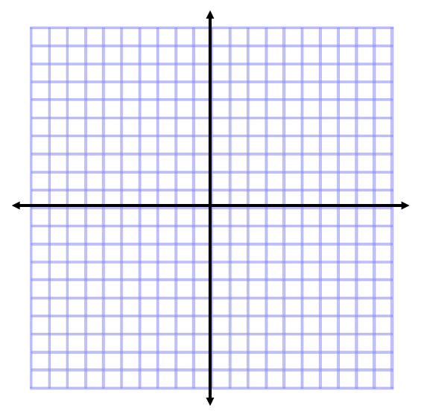
- $y=1;x=\frac{1}{3}$

$$x$$ | $$y$$
0
1
2
3
4

- $y=2;x=4$

$$x$$ | $$y$$

- $y=1;x=1$

$$x$$ | $$y$$

Score:__________________%

7.7 I can write and solve a proportion and use direct variation to represent real-life problems.
1. 8 rolls of paper towel cost $14.08. How many rolls can you buy for $21.12
Proportion: | Answer:
Constant of Proportionality (k): | Direct Variation Equation:
2. Joseph drives 125 miles in 25 hours. At the same rate, how far will he be able to drive in 6 hours?

Proportion: | Answer:
Constant of Proportionality (k): | Direct Variation Equation:
3. One hundred people attend a school fundraiser. The school earns $2500 from ticket sales. How much money will be raised from ticket sales if 500 people attend next year?

Proportion: | Answer:
Constant of Proportionality (k): | Direct Variation Equation:
4. If recycling 2006 pounds of paper saves 17 trees, how many trees are saved when 5000 pounds of paper are recycled?

Proportion: | Answer:
Constant of Proportionality (k): | Direct Variation Equation:
 | Score:_______________%

